***Blood Bank Management System***  
Chapter: 1

**Introduction**

The Blood Bank Management System is to create an e-Information about the donor and organization that are related to donating the blood. Through this application any person who is interested in donating the blood can register himself in the same way if any organization wants to register itself with this site that can also register. Moreover if any general consumer wants to make request blood online he can also take the help of this site. Admin is the main authority who can do addition, deletion, and modification if required.

**1.1 Problem Statement**

**Existing System**

* No use of Web Services and Remote Apps.
* Risk of mismanagement and of data in manual system.
* Less Security.
* No proper coordination between different Applications and Users.
* Fewer Users – Friendly

**1.2 Proposed Solution**

The proposed system, Online Blood Bank site overcomes the drawbacks of the present system.  The Blood Bank helps the people who are in need of a blood by giving them overall details regarding the donors with the same blood group and within their city.

The advantages of the proposed system are listed below.

* The people in need of blood can search for the donors by giving their blood group and city name.
* It is very flexible and user friendly.
* The person’s time and work is reduced very much which prevails in the present system.
* Easy and Helpful.
* The people are not limited to receive or provide services in working hours of the branch only; he is serviced 24 hours a day, 7 days of week and 365 days of the year.

**Advantages:**

* User friendly, it’s provided in the application with various controls.
* The system makes the overall project management much easier and flexible.
* Readily upload the latest updates, allows user to download the alerts by clicking the url.
* It provides high level of security with different level of authentication.

**1.2.1 Specific Objectives**

* An easy way to search the nearest blood banks to the accident site with the help of GPS.
* An effective way to find out the availability of the required blood groups in the blood banks.
* A proficient way to search the volunteer blood donors.
* Providing tips regarding the necessary measures that are to be taken before the blood donation.

Chapter: 2

**Related Projects**

**2.1 Related Project 1:** Hospital Management System

A Hospital Management System is an integrated information system for managing all aspects of a hospital's operations such as medical, financial, administrative, legal, and compliance. It includes electronic health records, business intelligence and revenue cycle management.

**2.2 Related Project 2:**  Medical Store Management System  
Drug Store Management and Rational Drug. Drugs & Medicines being expensive and resources limited, it becomes imperative to improve their supply, increase the use, and minimize the cost through a pharmaceutical management system to be effectively put in place.

Chapter: 3

**System Analysis**

First in the system development process is preliminary Investigation.  Preliminary Investigation is conducted in the following phases.

* Project clarification
* Feasibility study
* Project appraisal

Project clarification is the process of selecting a project request for further study.  When a system development or modification request is made, the first systems activity, the preliminary investigation, begins the activity has three parts: Request clarification, feasibility study and project appraisal.  Many requests from employees and users in organization are not clearly stated.

Therefore before any systems investigation can be considered, the project request must be examined to determine preciously what the originator wants.  This is called Request clarification.

As important outcome of the preliminary investigation is the determination that the system request in feasible.

**3.1.0 Feasibility Study**

The feasibility study is performed to determine whether the proposed system is viable considering the Technical, Operational and Economical factors. After going through feasibility study we can have a clear-cut view of the system’s benefits and drawbacks.

* Technical feasibility
* Economic feasibility
* Operational feasibility

**3.1.1 Technical Feasibility:**

The proposed system is developed using Active Server Page, JavaScript and HTML as front-end tool and PHP as the back end. The proposed system needs a Personal Web Server to serve the requests submitted by the users. The Web browser is used to view the web page that is available within the Windows and other operating system itself, And all other web browsers. All the required hardware and software are readily available in the market. Hence the system is technically feasible.  
  
**3.1.2 Operational Feasibility:**

The proposed system is operationally feasible because of the following reasons.

* The customer is benefited more as most of his time is saved.  The customer is serviced at his place of work.
* The cost of the proposed system is almost negligible when compared to the benefits gained.

**3.1.3 Economical Feasibility:**

As the necessary hardware and software are available in the market at a low cost, the initial investment is the only cost incurred and does not need any further enhancements.  Hence it is economically feasible.

The system is feasible in all respects and hence it encourages taking up the system design.

**3.2.0 Requirements Gathering**  
Requirement means what the need of the project is. It may range from a high-level abstract statement of a service or of a system constraint to a detailed mathematical functional specification. It begins from communication and continues to modeling. The analysis through collection of data plays the wider role in the analysis of the system.  So the data is collected at different levels of management to keep track of full information of the system.

**3.2.1 Functional Requirements**

In this system there will be four types of Users

1. Admin
2. Blood Bank
3. Blood Donor
4. Patient

* There will have some functions like Add Blood Donor Information, Edit Blood Donor Information, Add Blood Bank, Blood storage, Adjustment and Reporting. Every function has one or more sub-functions.
* Sub-functions of Add Admin Information are
  + Add Blood Bank
  + Add Blood Category
  + Add Donor
  + Add Blood Supplier
* Sub-functions of Blood Bank are
  + Add Blood Donor
  + Branch Information
  + Add Branch
  + Add Blood Supplier
  + Add Storage
* Sub-functions of Blood Donor are
  + Blood Report
  + Personal Information
* Sub-functions of Patient are
  + Request Blood
  + Personal Information
* Every user has different access
  + Admin can access everywhere
  + Blood bank can access Donor and Patient Information

**3.2.2 Non-Functional Requirements**

* Check database connection
* Insure Blood Information conflict
* Check availability of blood in storage
* Check previous donation date of donor
* Authenticate user

**3.3 Observation**

The data is also collected by observation of the firm.  The data is collected by observing on the site at different timings and at different situations like when the firm is busy and when the firm hasn’t much work to do.

**3.4 Questioners**

The data is collected through questioners by filling a set of questions from the different levels of management. The questions made by questioners are three different types.

They are,

**Structured questioners:**

**Unstructured questioners:**

**Semi-structured questioners:**

**3.5 Interviews**

Interviews were conducted to collect the information.  The interviews were conducted at two levels.

1. *Formal Group Interviews:*  the interviews conducted for formal groups i.e., the hierarchical (official) groups in the firm.
2. *Informal Group Interviews:*  the interviews were conducted for informal groups   i.e., the groups formed outside the company.

Chapter: 4

**4.1 Use Case Diagram**

A use case diagram at its simplest is a representation of a user's interaction with the system that shows the relationship between the user and the different use cases in which the user is involved.

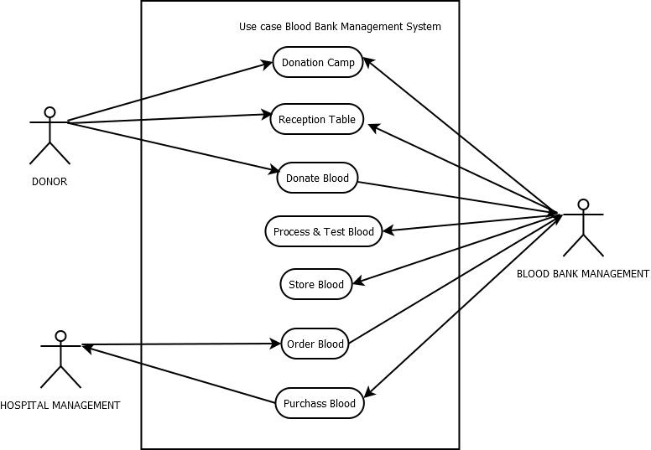

**4.2 Activity Diagram**

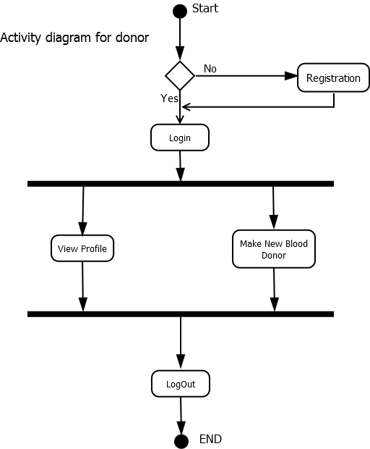

**4.3 Sequence Diagram**

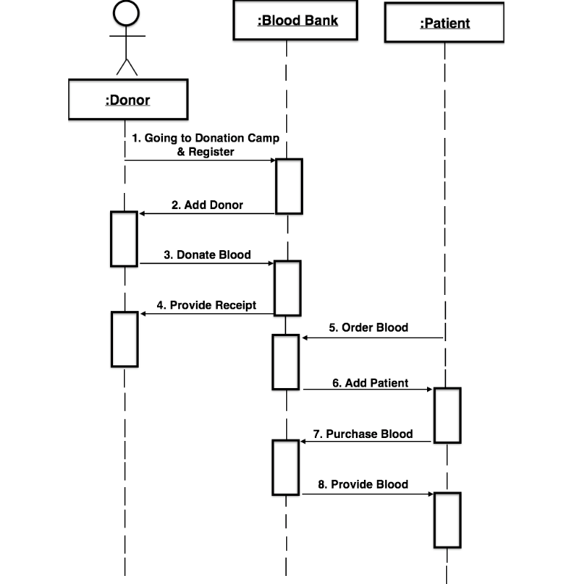

**4.4 Class Diagram  
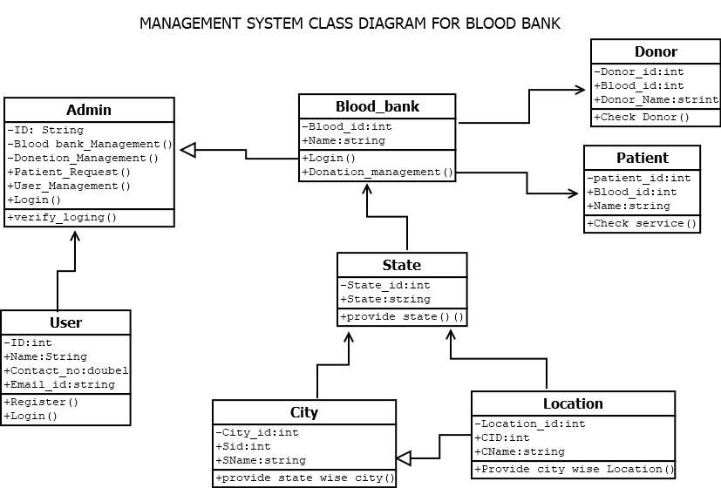**

Chapter: 5

**5.1 Implementation Evaluation**

During the software-testing phase each module of software is thoroughly tested for bugs and for accuracy of output. The system developed is very user-friendly and the detailed documentation is also given to the user as online help wherever necessary.  The implementation phase normally ends with the formal test involving all the components.

The entire system was developed using the PHP, HTML, JavaScript, Personal Web Server, and MySql as back end. The HTML is used to design the web page. The Personal Web Server is used to understand the client’s request and to send response to them. The JavaScript, are used for client-side validations so that the user can enter only appropriate input in the input fields. The MySql is the back end tool where the database resides.

Hence the design of the entire system is user-friendly and simple the implementation has been quite easy.

Chapter: 6

**6.1 Conclusion**

This project has given us an ample opportunity to design, code, test and implements an application. This has helped in putting into practice of various Software Engineering principles and Database Management concepts like maintaining integrity and consistency of data. Further, this has helped me to learn more about MySql, PHP, HTML, JavaScript, Adobe Photoshop 7.0 and Personal Web Server.

I thank my guide for his invaluable contribution in guiding me throughout the project.  I also thank my teacher and friends who have supported and motivated me to complete this project successfully.